BUSINESS PLAN TEMPLATE
Applied Software Development – University of the Highlands and Islands

MAUISCREENTIME

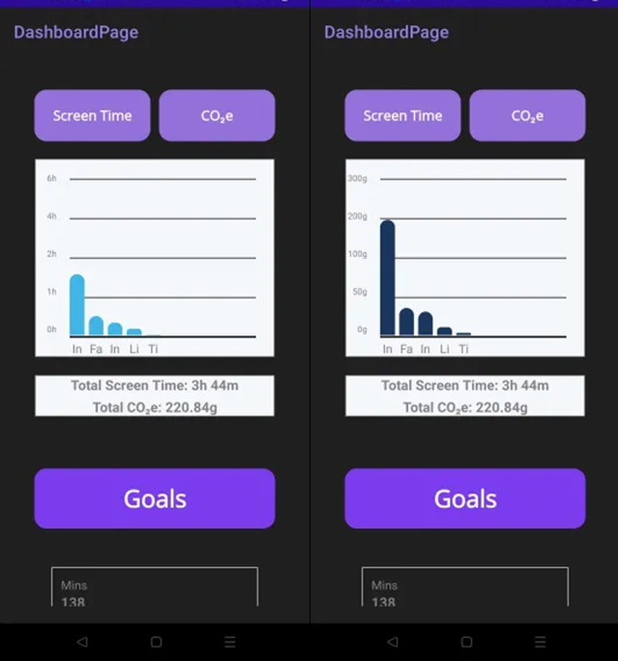

Contents
MAUISCREENTIME 1
Executive Summary 3
1. Business Description 3
2. Market Analysis 4
3. Competitor Analysis 4
4. Marketing & Sales Strategy 5
5. Product Development & Technology 6
6. Operations Plan 6
7. Financial Plan 6
8. Risk Analysis 7
9. Meta Skills Reflection 8
Conclusion 9
References 10

Executive Summary
MauiScreenTime is a screen time tracker specifically for social media apps, that gives carbon insights into the users screen time and aims to incentivise screen time reduction by offering goals like planting trees per x amount of CO2eg reduced. The goal is to create informed consumers who feel more empowered to control their consumption of highly addictive social media apps, while contributing directly to domestic conservation efforts and reducing their carbon footprint.

Business Description
MauiScreenTime aims to mitigate social media and general phone overuse in a way that promotes digital wellbeing, encourages carbon literacy and reconnects users with the natural world.
Media apps are designed for endless scrolling, but every minute carries an unseen cost – to our attention, wellbeing, and the planet. The MauiScreenTime app aims to equip users with an oversight of the greater impact of their digital habits, and empowering user with tools to mitigate phone overuse and become more informed consumers of social media. The app has currently received full funding for the proof-of-concept stage from Prickly Thistle and UHI’s REBEL Fund, this will fund publishing the product and handling the tree-planting operations that provides user incentives for screen time reduction using the app mechanics.
The application converts user social media screen time into each products relative carbon equivalent cost in grams, and pledges to plant a tree for each time the users reduction goal is met.
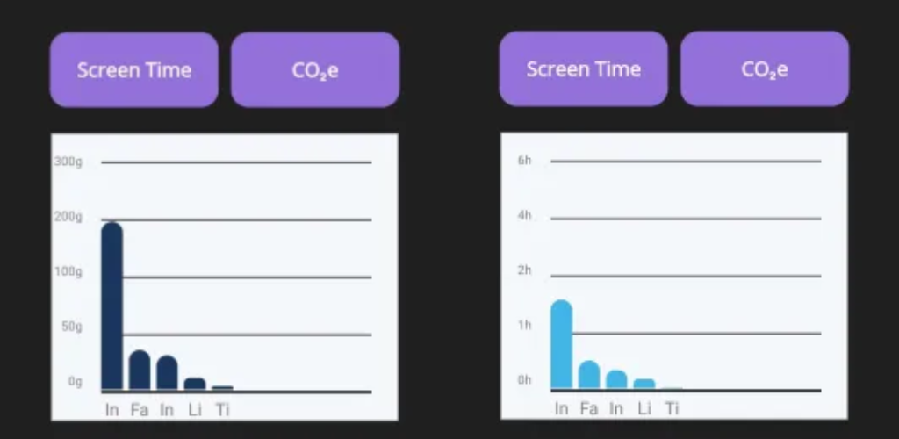

Market Analysis
The target market along with customer segments has been identified and explored in the Market Analysis report, where the target audience was identified as adults aged 27 - 37, but also with a wider audience of young and old mobile social media users who are environmentally conscious and want to reduce their screen time. User segments are further broken down in Section 3 of the report.
(https://github.com/TortoiseLeaf/laurenk_personal_repository_2025/blob/main/UI_Software_Delivery_and_Team_Management/Marketing-plan-Maui.docx)

Competitor Analysis
A Competitor Analysis was completed in order to understand existing solutions already within the market landscape. This is useful to clearly identify market areas already met by competitor products, along with undeserved areas of the market where MauiScreenTime can fit to serve the customer-base in areas underserved by other competitors.
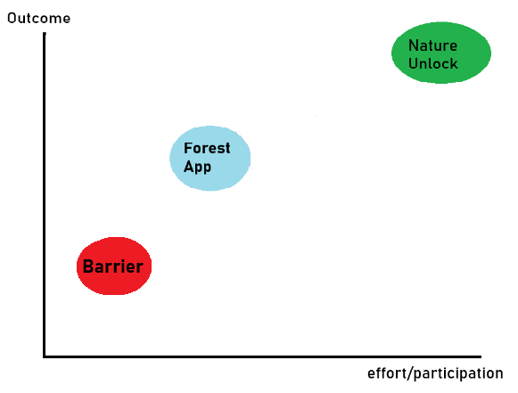
Figure 1: Group Mapping Analysis (Keenan, 2026)
Measured against axes of user effort/participation vs the outcome of the participation, there are two distinct groups.
A competitor analysis was also created around this research (https://github.com/TortoiseLeaf/laurenk_personal_repository_2025/blob/main/UI_Software_Project_Management_Lifecycles/Competitive-Analysis.pdf)
Nature Unlock requires users to go outside, take a picture of a tree and upload it to unlock their phones. This is a high effort, high yield model of operation that rewards the user with a healthy beneficial experience.
Forest App is a lower effort and moderate yield service which encourages users to use their pomodoro-style timer by “growing” a virtual tree for the duration of the timer, restricting access to other apps.
Barrier is a low effort, low yield solution that interrupts the user from their digital habits by locking apps with a timer and requiring adverts to be watched in order to unlock the application.
From this analysis it can be determined there are two distinct areas that can be moved into: High effort low yield and low effort high yield.
As our application requires mostly passive participation and offers a high-impact physical outcome comparative to competitors, I think MauiScreenTime could fit well into the low effort, high yield corner of the market.

Marketing & Sales Strategy
The application will be promoted to the Inverness Campus of the Scottish School of Forestry, where I will pitch and include an instructional promo video of how the application works. (https://vimeo.com/1178875380?share=copy)
It will also be advertised to students across UHI using Handshake and promotional materials such as digital flyers
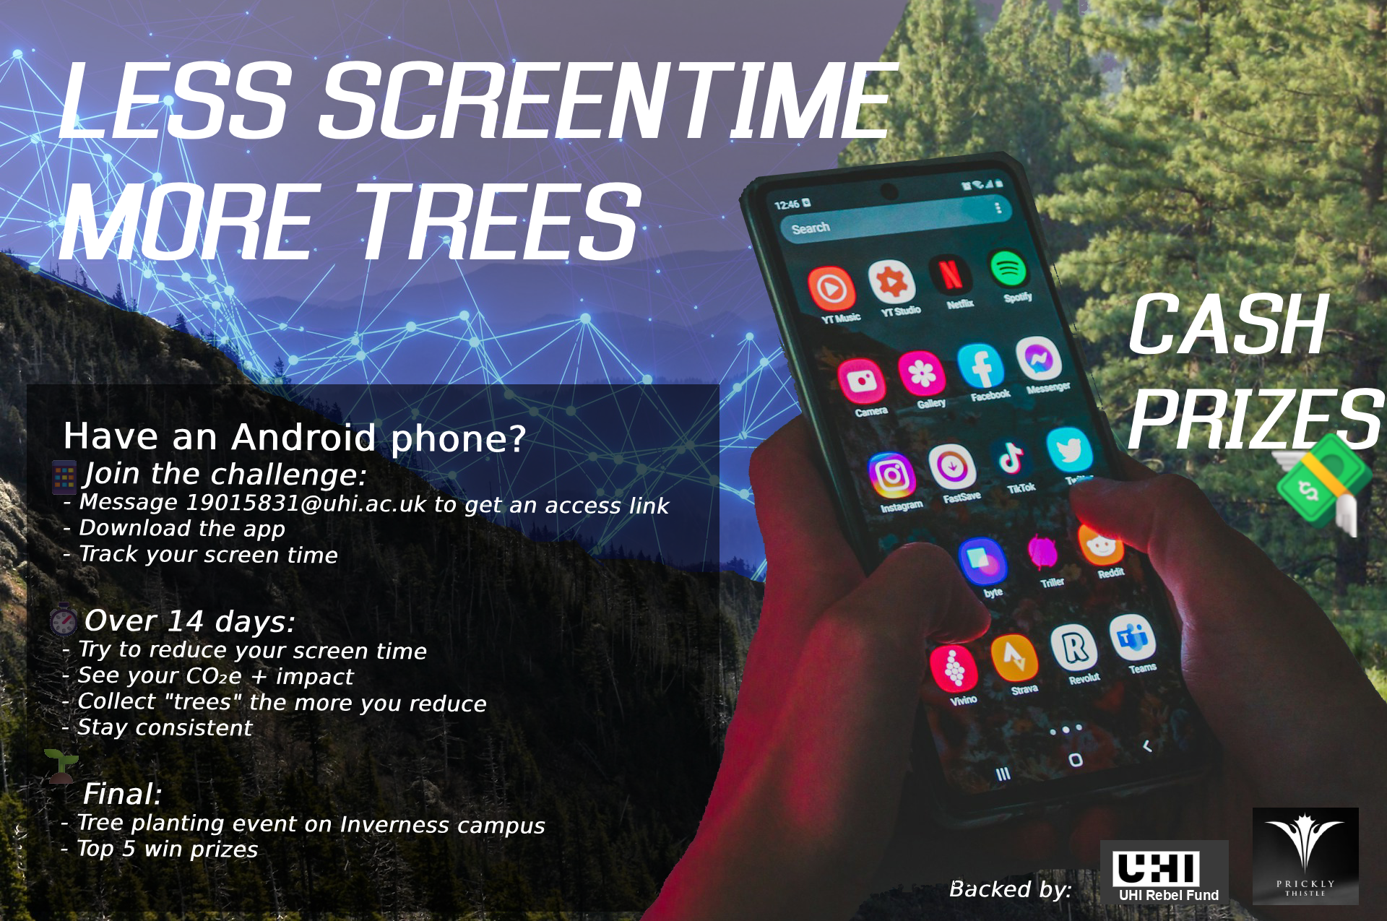
This will also be advertised on LinkedIn to target the wider network of the focussed target audience of 27 - 37 year olds. Monetised user incentives are also advertised for participating, 1st, 2nd, 3rd prize for who can plant the most trees, with runners up prizes to the top 5 contributors.
Research was conducted into advertising costs on Meta for a social media presence for the application, where the product can advertise to the target audience in channels they are most likely to see it as per the user segments of young people and 27 - 37 year olds who use social media apps. Costs are difficult to pin down as they vary based on engagement and clicks, so because of this with the current round of funding this will be excluded and we will instead focus on holistically advertising within UHI using official university channels and affiliates like Handshake to promote the app and the beta-testing.

Product Development & Technology
The software solution tracks user screen time spent on Social Media apps, quantifies it into CO2eq, and gamifies the reduction of screen-time with the incentive of planting trees for x amount of CO2eq “saved” from a decrease in use of social media applications.
To support this, the project main features are a user consent system to allow for legal data collection, a screen time usage collection service, CO2eq conversions with numerical goals and milestones, and a dashboard for reporting this data.
The project uses C# .NET MAUI cross-platform framework with SQLite for local, on-device data storage, and the source code is hosted on Github for source control. The project follows Agile Scrum, with frequent feedback loops from stakeholders and team members at the end of sprints to inform development as it moves forward.

Operations Plan
Four releases of the project from initial design planning to fully tested release span at around 2 months each, prioritising core application logic and then refining it into an intuitive and effective UI/UX. The resources used are student manpower, guidance from delivery staff and using Github source control with JIRA for project management, the Visual studio IDE and MS Teams to communicate. The daily operations of the project are to check communications, work from JIRA tickets in Visual Studio and to commit progress to Github.
A Competitor analysis was conducted also to look at the retention and advertising models used by competitors. While NatureUnlockApp uses a directed call-to-arms in its listing description to target the audience who will specifically benefit from the app. This could be used in the MauiScreenTime listing to keep user retention high by ensuring the targetted audience is invited to use the app specifically, and potentially help to reduce bounce or churn by being transparent with what the app does thereby filtering out users outwith the target audience.
The Forest App created an online community on Reddit to keep their user base engaged and to stoke interest in the competitive gamification of the apps fundamental mechanics. This has proven useful for user retention as the subreddit began in 2017 and is still in use, and a similar idea could be adopted for keeping beta-testers of the MauiScreenTime app engaged with the testing.
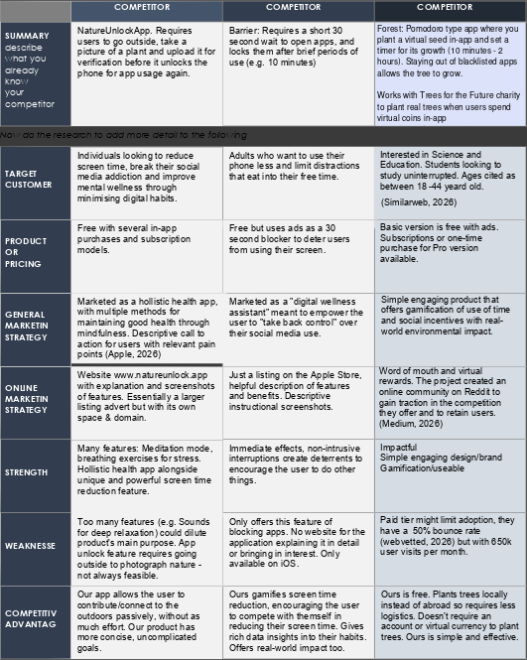

Financial Plan
Estimate development costs, projected revenue (if applicable), and resource allocation.
Add Budget tracker here?
Include budget tables, break-even analysis, and assumptions if possible.
– Ben will help with
Budget for rebel fund (Lois wants it to show how it’s funded)
Current funding for the project proof of concept includes £2500 from Prickly Thistle.
The funding stipulation excludes coursework from payment, and so only non-technical elements of the project development will be funded. Funding also excludes paid labour, and therefore only materials and event support are funded.
It’s estimated the average cost for a recommended 1000-1600 trees per hectare is around £900-2000 (https://www.woodlandtrust.org.uk/plant-trees/trees-for-landowners-and-farmers/morewoods/#:~:text=On%20average%2C%20self%2Dplanted%20projects,landowner%20around%20%C2%A3900%2D2%2C000.)
Around this estimate and adhering to the funding available, a cash-flow document has been created.
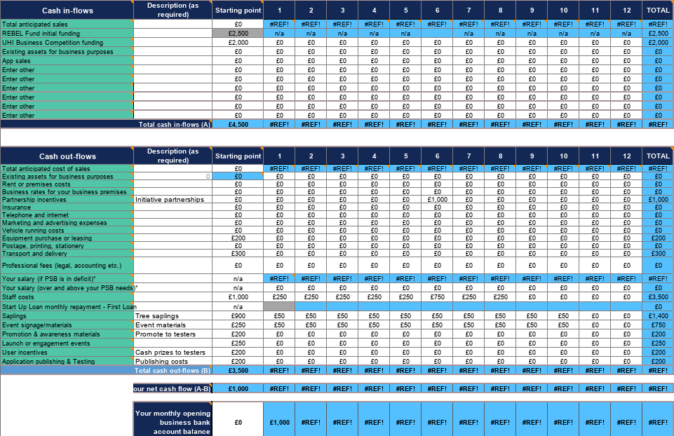
(https://github.com/TortoiseLeaf/laurenk_personal_repository_2025/blob/main/UI_Software_Project_Initiation_and_Planning/cash-flow-maui.xlsx)
For further development beyond the proof of concept, further avenues of funding have been researched in UHI’s Staff & Student enterprise fund, where a further £3000 - £5000 has been applied for in order to support feature development and integration of user feedback to strengthen and stabilise the platform.
Beyond strengthening the proof-of-concept, UHI’s converge competition has been considered for long term maintenance and future development of the project, including exploring avenues of partnership with more local conservation initiatives and eventually modelling the software for enterprise adoption.

Risk Analysis
A risk register was made with the team to identify, prioritise and offer mitigations for various risks to both development and project management, and also to external operations of the project such as the conservation event. (Keenan, 2025)
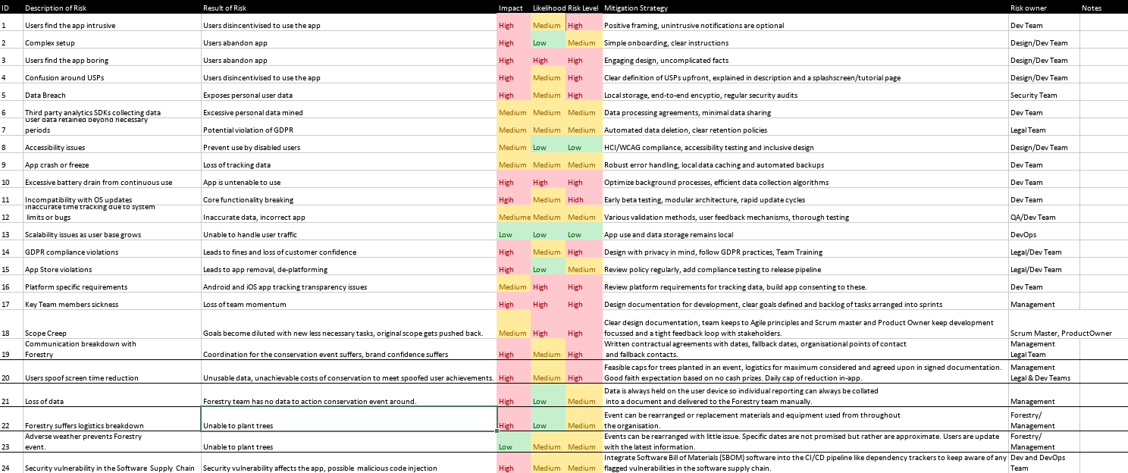

Meta Skills Reflection
Skills I identified as weaker and to develop have been leading, collaborating, critical thinking and initiative. In developing these skills I’ve improved my leading skills by becoming more conscientious when collaborating. I am better understanding when and how to lead and what is necessary to step forward into, in order to push development forward.
Focussing on leading and collaborating has greatly improved my critical thinking, as discussing a topic with other people allows me to see it from different perspectives. This allows different skill-sets to consider a problem too.
Sharing the responsibility for ideas also takes the weight of sole responsibility away, and gives more mental bandwidth to consider the topic critically.
Leading and collaborating have also informed my skills with initiative and I’ve noticed a big development with this skill. Understanding my place at different levels within a team gives a greater insight into where I fit and can create more effective and positive change.
These weaker skills have been developed under duress, in managing stakeholder expectations with team members and personal resources. Understanding what to communicate and when has helped me have a better idea of how to employ certain skills and that in turn has helped me develop them.
Progress is documented in the meta skills pdf

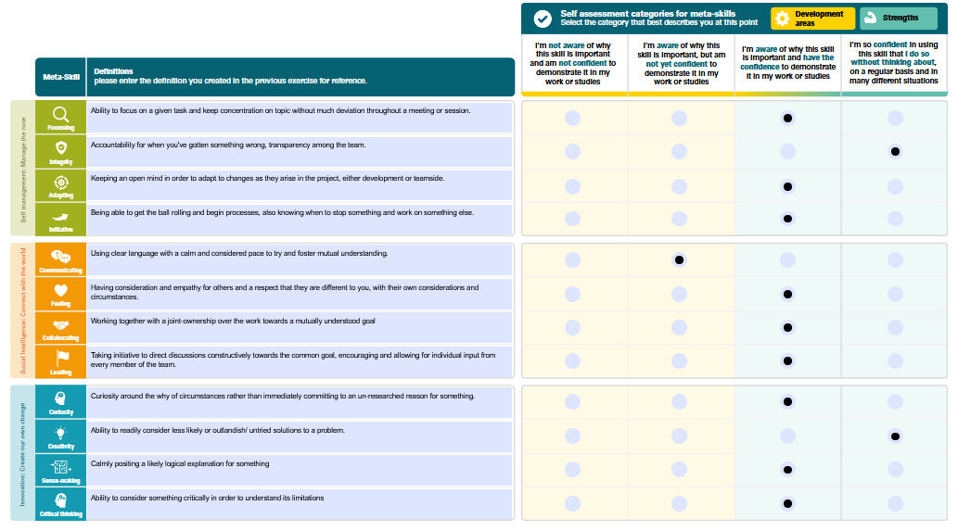
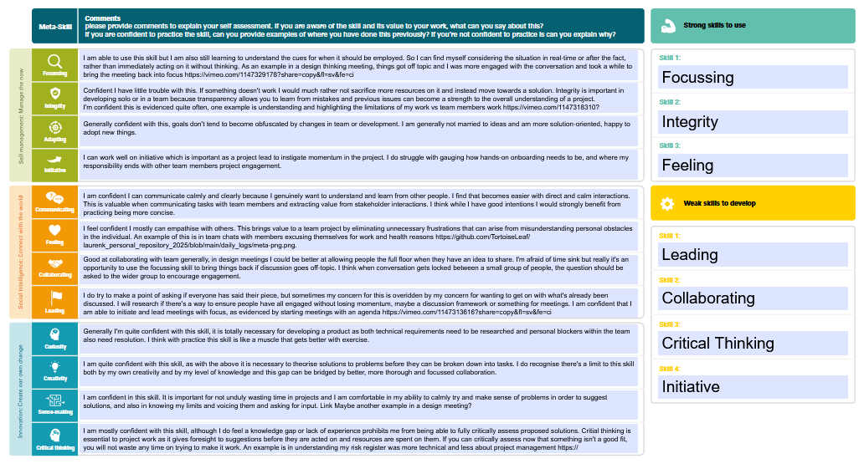
(https://github.com/TortoiseLeaf/laurenk_personal_repository_2025/blob/main/UI_Software_Project_Management_Lifecycles/Lauren%20Keenan%20Self%20assessment%20tool%20final.pdf)

Conclusion
The overall value of the project is as a health app helping users to reduce their screen time on deliberately addictive social media applications, whilst also directly contributing to local conservation efforts. The application provides insights into user data, and real-world carbon-positive actions that could be adapted for enterprise adoption in future for businesses that want to reduce their scope 3 emissions and potentially collect carbon credits.
Next steps include stabilising the prototype by integrating user feedback from beta testing, and strengthening a brand identity and presence by developing partnerships with local conservation initiatives.

References

Keenan, L. (2025) laurenk_personal_repository_2025/UI_Enterprise_Transformation /LO1.xlsx, laurenk_personal_repository_2025/UI_Enterprise_Transformation /LO1.xlsx at main. Available at: https://github.com/TortoiseLeaf/laurenk_personal_repository_2025/blob/main/UI_Enterprise_Transformation/LO1.xlsx (Accessed: 26 November 2025).

